**Note:** refer Assignment1 for Works_on and Project table etc.

1. Create a non-clustered index for the enter_date column of the works_on table.

Sixty percent of each index leaf page should be filled.

--1. Create a non-clustered index for the enter_date column of the works_on table. Sixty percent of each index leaf page should be filled.

IF EXISTS (SELECT name FROM sys.indexes

WHERE name = N'IX_Work_Enterdate')

DROP INDEX IX_Work_Enterdate ON [dbo].[Works_on];

GO

CREATE NONCLUSTERED INDEX IX_Work_Enterdate

ON [dbo].[Works_on] (enter_date)

WITH (FILLFACTOR = 60);

Go

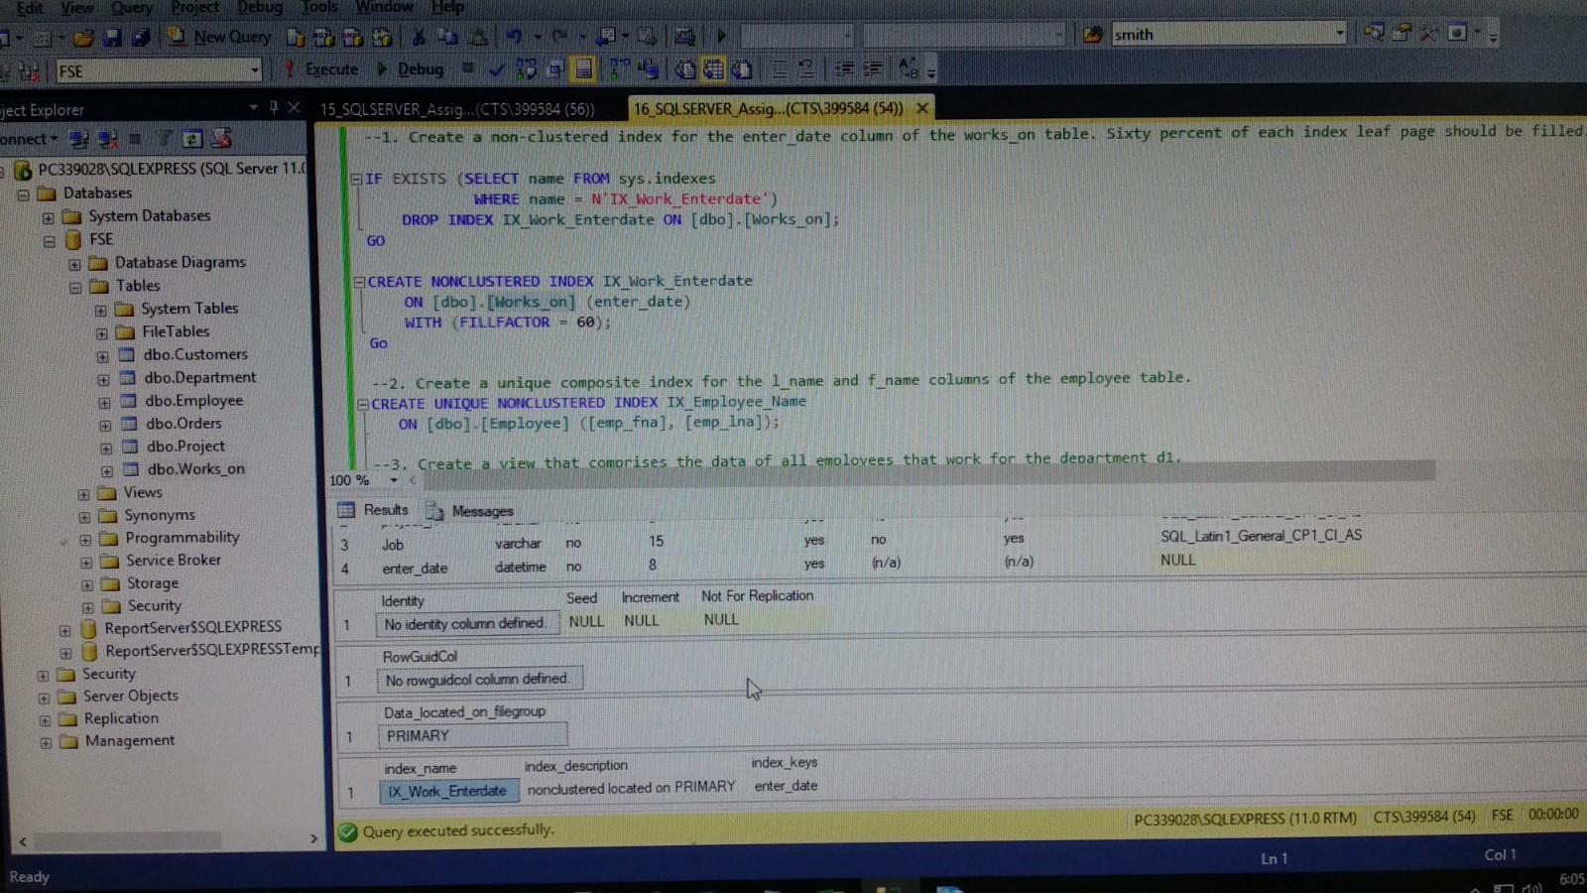

1. Create a unique composite index for the l_name and f_name columns of the employee table.

--2. Create a unique composite index for the l_name and f_name columns of the employee table.

CREATE UNIQUE NONCLUSTERED INDEX IX_Employee_Name

ON [dbo].[Employee] ([emp_fna], [emp_lna]);

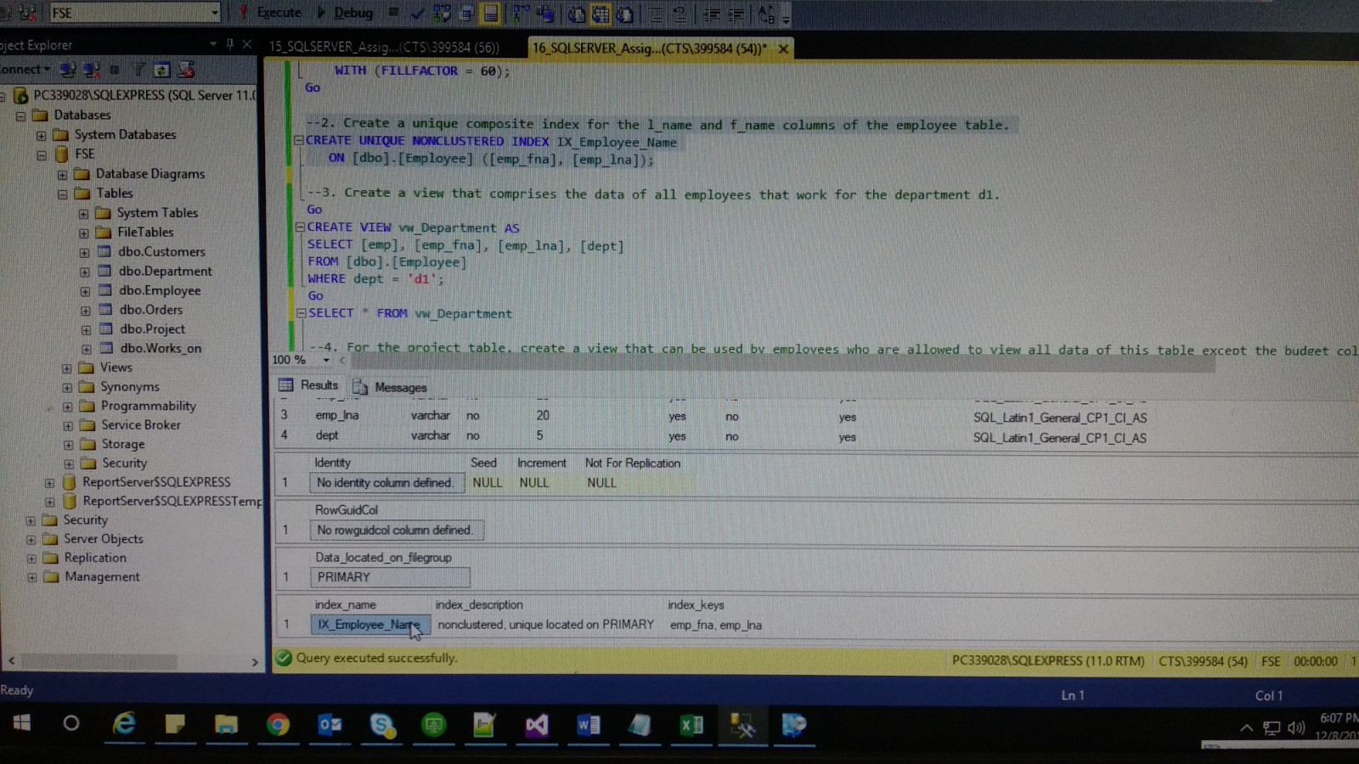

1. Create a view that comprises the data of all employees that work for the department d1.

--3. Create a view that comprises the data of all employees that work for the department d1.

Go

CREATE VIEW vw_Department AS

SELECT [emp], [emp_fna], [emp_lna], [dept]

FROM [dbo].[Employee]

WHERE dept = 'd1';

Go

SELECT * FROM vw_Department

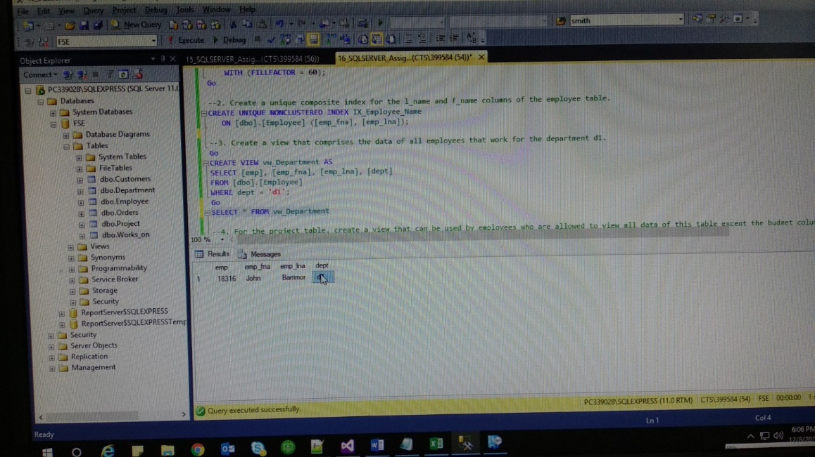

1. For the project table, create a view that can be used by employees who are allowed to view all data of this table except the budget column.

--4. For the project table, create a view that can be used by employees who are allowed to view all data of this table except the budget column

Go

CREATE VIEW vw_Project AS

SELECT [prjid], [project_na]

FROM [dbo].[Project];

Go

SELECT * FROM vw_Project;

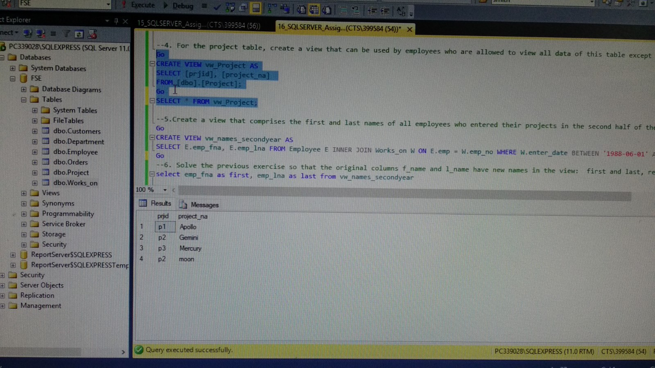

1. Create a view that comprises the first and last names of all employees who entered their projects in the second half of the year 1988.

--5.Create a view that comprises the first and last names of all employees who entered their projects in the second half of the year 1988.

Go

CREATE VIEW vw_names_secondyear AS

SELECT E.emp_fna, E.emp_lna FROM Employee E INNER JOIN Works_on W ON E.emp = W.emp_no WHERE W.enter_date BETWEEN '1988-06-01' AND '1988-12-31';

Go

SELECT * FROM vw_names_secondyear

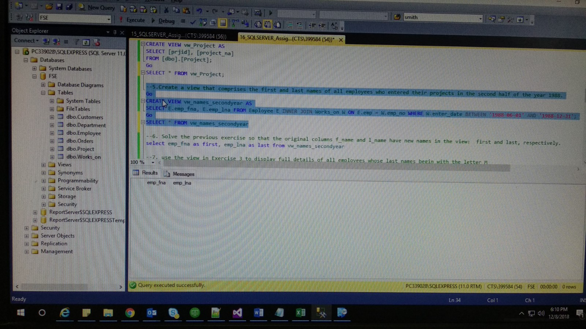

1. Solve the previous exercise so that the original columns f_name and l_name have new names in the view: first and last, respectively.

--6. Solve the previous exercise so that the original columns f_name and l_name have new names in the view: first and last, respectively.

select emp_fna as first, emp_lna as last from vw_names_secondyear

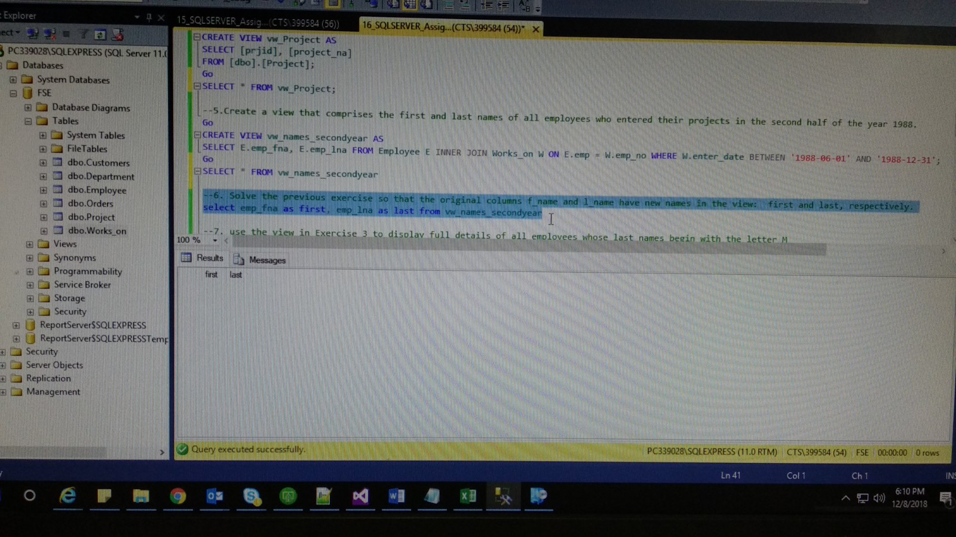

1. use the view in Exercise 3 to display full details of all employees whose last names begin with the letter M.

--7. use the view in Exercise 3 to display full details of all employees whose last names begin with the letter M

SELECT * FROM vw_Department where emp_lna like 'M%'

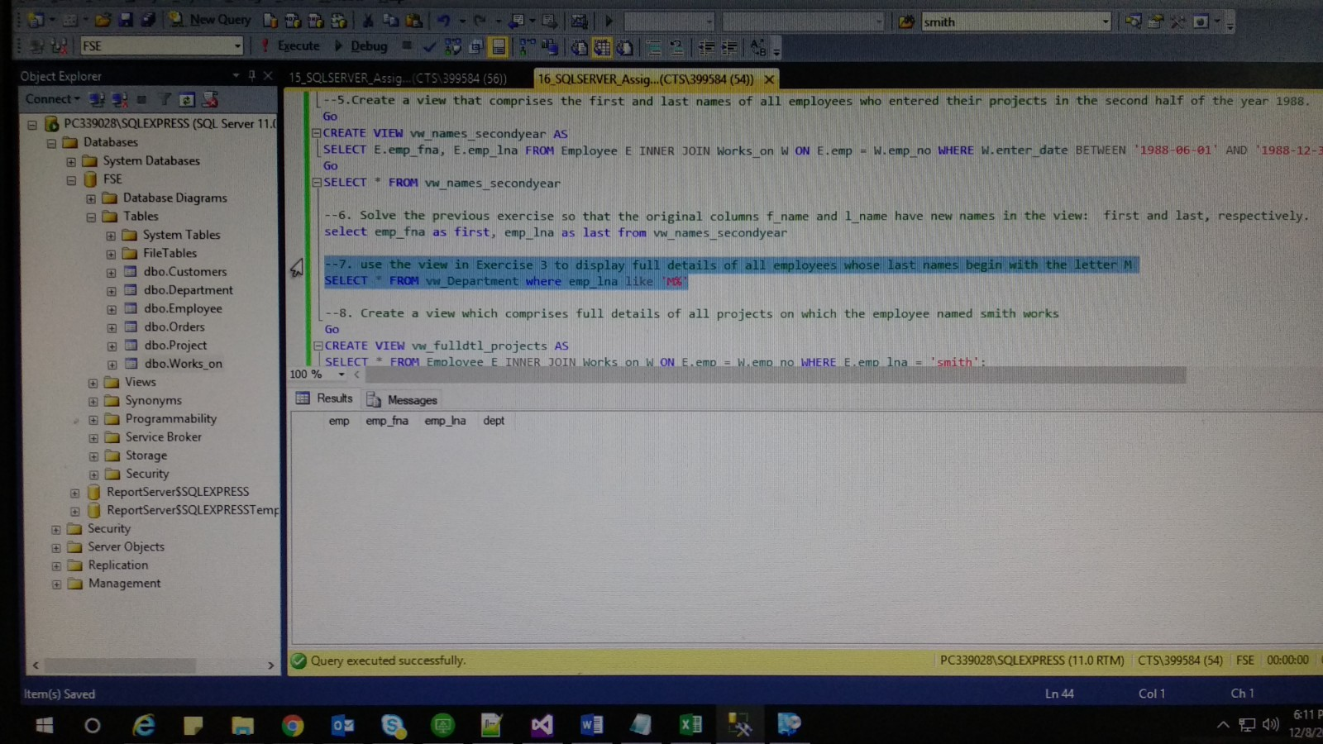

1. Create a view which comprises full details of all projects on which the employee named smith works.

--8. Create a view which comprises full details of all projects on which the employee named smith works

Go

CREATE VIEW vw_fulldtl_projects AS

SELECT * FROM Employee E INNER JOIN Works_on W ON E.emp = W.emp_no WHERE E.emp_lna = 'smith';

Go

SELECT * FROM vw_fulldtl_projects

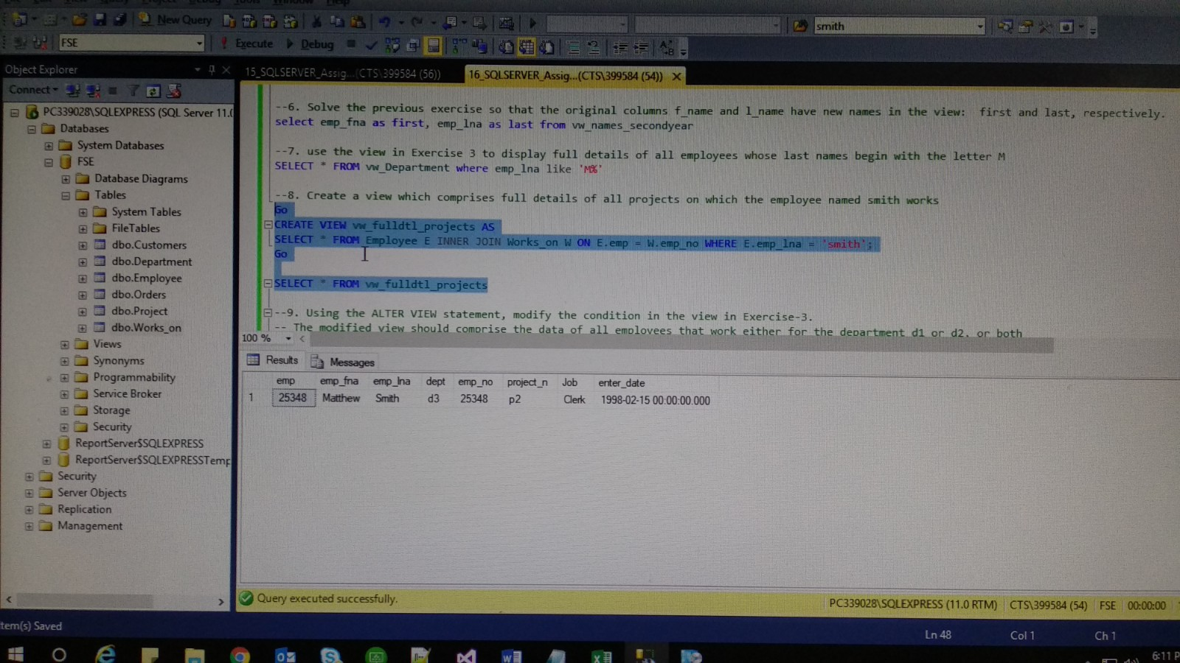

1. Using the ALTER VIEW statement, modify the condition in the view in Exercise-3. The modified view should comprise the data of all employees that work either for the department d1 or d2, or both.

--9. Using the ALTER VIEW statement, modify the condition in the view in Exercise-3.

-- The modified view should comprise the data of all employees that work either for the department d1 or d2, or both

Go

ALTER VIEW vw_Department

AS

SELECT * FROM Works_on W INNER JOIN Employee E ON E.emp = W.emp_no WHERE E.dept in( 'd1','d2');

GO

SELECT * FROM vw_Department

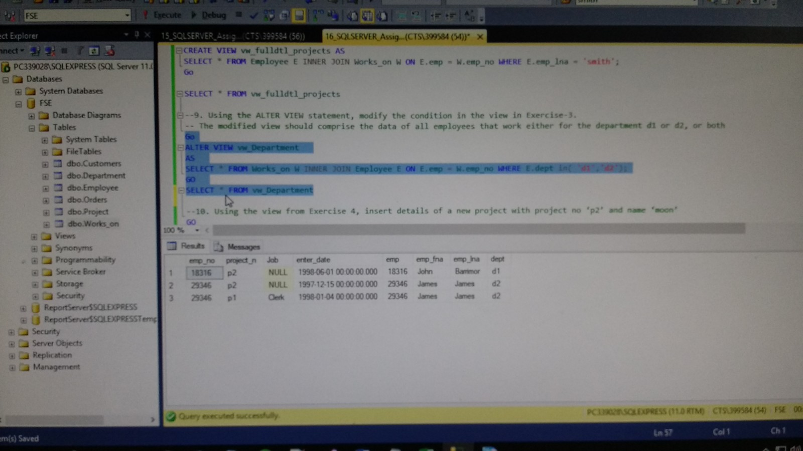

1. Using the view from Exercise 4, insert details of a new project with project no ‘p2’ and name ‘moon’

--10. Using the view from Exercise 4, insert details of a new project with project no ‘p2’ and name ‘moon’

GO

INSERT INTO vw_Project (prjid, project_na)

VALUES ('p2', 'moon');

GO

SELECT * FROM vw_Project

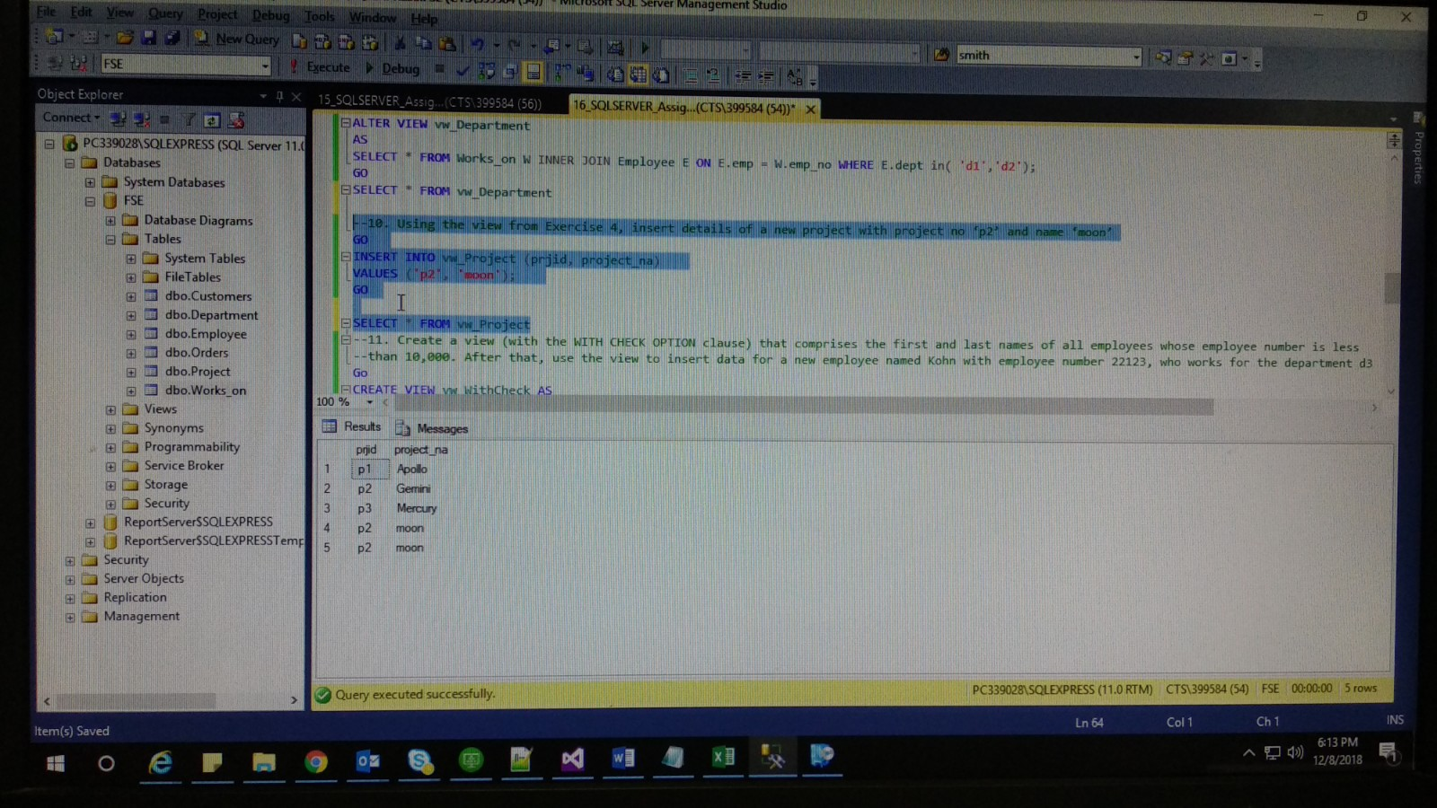

1. Create a view (with the WITH CHECK OPTION clause) that comprises the first and last names of all employees whose employee number is less than 10,000. After that, use he view to insert data for a new employee named Kohn with the employee number 22123, who works for the department d3.

--11. Create a view (with the WITH CHECK OPTION clause) that comprises the first and last names of all employees whose employee number is less

--than 10,000. After that, use the view to insert data for a new employee named Kohn with employee number 22123, who works for the department d3

Go

CREATE VIEW vw_WithCheck AS

SELECT emp_fna, emp_lna FROM Employee E WHERE emp < '10000'

WITH CHECK OPTION;

Go

SELECT * FROM vw_WithCheck

INSERT INTO vw_WithCheck (emp_fna, emp_lna) VALUES ('Balaji', 'Singh');

INSERT INTO Employee VALUES('22123', 'Kohn', '', 'd3')

INSERT INTO vw_WithCheck VALUES('Check', 'Kohn')

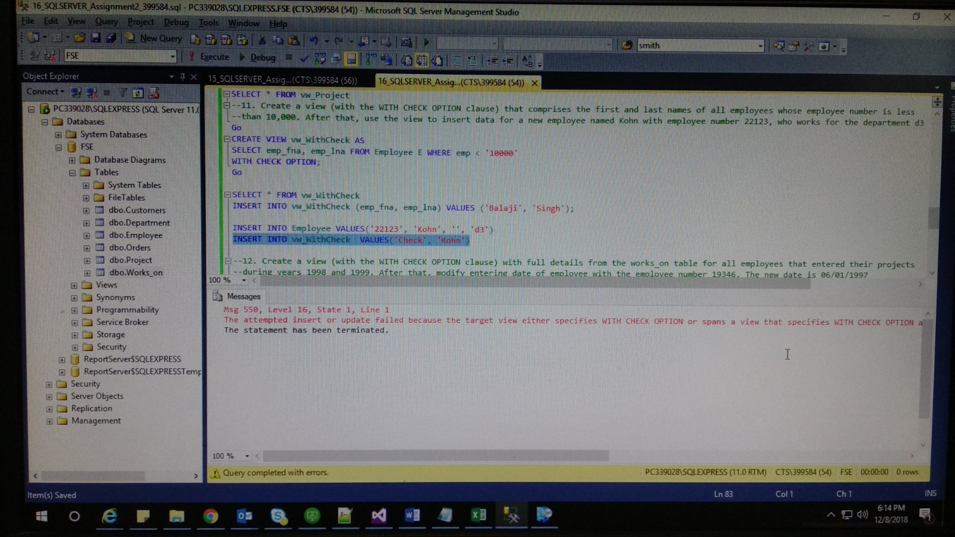

1. Create a view (with the WITH CHECK OPTION clause) with full details from the works_on table for all employees that entered their projects during the years 1998 and 1999. After that, modify the entering date of the employee with the employee number 19346. The new date is 06/01/1997.

--12. Create a view (with the WITH CHECK OPTION clause) with full details from the works_on table for all employees that entered their projects

--during years 1998 and 1999. After that, modify entering date of employee with the employee number 19346. The new date is 06/01/1997

Go

CREATE VIEW vw_WorkChk AS

SELECT * FROM Works_on WHERE enter_date between '1998-01-01' and '1999-12-31'

WITH CHECK OPTION;

Go

INSERT INTO vw_WorkChk VALUES('19346', 'p3', 'Analyst', '1999-01-01')

UPDATE vw_WorkChk SET enter_date = '1997-06-01' WHERE emp_no = '19346';

SELECT * FROM vw_WorkChk

SELECT * FROM Works_on

